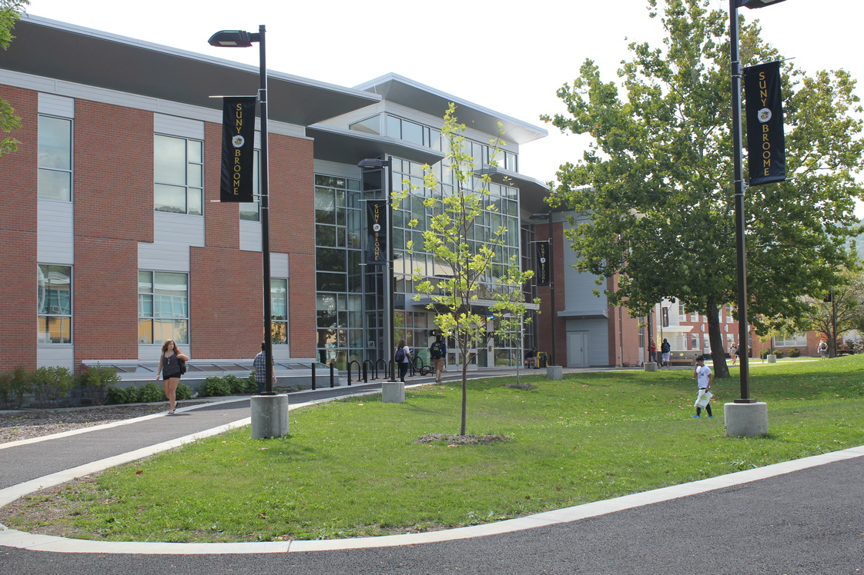

SUNY Broome Community College
Administrative Organizational Structure- Evaluation
2019
Dr. James Magee

SUNY Broome Community College
Administrative Organizational Structure – Evaluation
October 31, 2019

Introduction:
Strategic Innovations in Education (SIE) was engaged to provide specific consulting services to SUNY Broome Community College (SBCC) that focused on the evaluation of current senior administrative and organizational structures for effectiveness and efficiencies. A team of nationally recognized consultants worked collaboratively with the President’s staff to examine several options in the formulation of an organizational structure that will maximize the achievement of institutional goals and future success. It should be noted that SIE was directed to limit its review to upper administrative positions.
The feedback from this report will be used to initiate a planning process with continued input representative of the entire community. No preconceptions were made and the opportunity to develop new models of an administrative structure that best serves the mission and vision of Broome was our goal.
An integral part of the evaluation process was the examination and analysis of several institutional documents such as:
- Copies of current enrollment marketing plans, assessments and annual reports, as well as retention initiative’s and results.

- A list of personnel on the President’s Executive Cabinet and a description of their function (job title), roles and responsibilities.

- Lists of all outsourcing agreements.

- Copies of previously completed surveys, studies and reports concerning the administration and organization function. This would include a copy of the most the most recent Middle States communications as well as the most recent SUNY Excel report, as well as other SUNY and SED reports.

- A list of all academic programs approved for implementation along with a copy any academic plans indicating future academic programs to be designed and approved.

- Copies of the latest enrollment report for each academic program on and off campus by semester. This would include applicant conversion yield rates as well as retention and graduation and job placement reports. Continuing Education and on-line enrollment data were reviewed.

- A description of all international enrollments and any plans to expand enrollment of academic programs internationally

- Copies of reports in the academic student support services area.

- Copies of the College’s current strategic planning documents and timelines for implementation, new facilities and initiatives.
.
- Copies of outcomes assessment reports plans and capacity that focus on mission, enrollment and academic quality.

- Copies of the Strategic Planning Committee and advisory committee memberships including contact information as well as minutes of recent meetings and the most recent strategic plan through 2022.

- Current organizational charts with titles and job descriptions, Board of Trustee policies, the mission statement, Middle States Self Study reports, and other state college organizational structures.

The Middle States Report (2010) and Institutional Reports recognized clear lines of organization and authority, a representative Strategic Planning Process, and ability to adapt to changes in leadership. It was recommended that annual or bi-annual reviews of administrative structures be conducted. Currently, SBCC is preparing the next comprehensive self-study and this administrative organizational structure evaluation will be an important part of Standard 5 as well as other areas.

Project Goals:
The primary goal of this evaluation of the current SBCC administrative organizational structure is to work towards creating a unique comprehensive and distinctive model that will maximize the achievement of the College’s mission, goals and future success as well as the vision, priorities, goals and objectives of the SUNY Broome Strategic Plan (2017-2022).
This effort focuses on an organizational structure and functions intended to assist the College in bringing together specific goals, tasks, implementation steps, assigned responsibilities and timeframes across administrative, academic and student service areas. The recommended structure will unite the efforts of all areas in the College to create efficiencies in operation and enables the College to link resource allocation decisions to opportunities and strategies aimed at student success.

Process:
Importantly, the evaluation process included feedback and perspectives on the current organizational structure from campus interviews and focus group discussions with the following;
- 32 Individual Interviews with staff and administration
- Focus Group Discussions with: Total of more than 124 Broome participants
  - The Think Tank Committee
  - College Assembly
  - Council on Academic Issues
  - Council on Operational Issues-
  - 2 Town Hall Meetings- 30 participants
  - Student Assembly Representatives
In addition, SIE conferred with several personnel by telephone and examined reports, evaluations, requested documents and recommendations from several offices and individuals. Individuals are not identified in any of the feedback processes. A position analysis and reporting structure was taken into consideration in examining options and making recommendations in alignment with Broome’s Mission & Vision, Strategic Plan, comparative SUNY CC structures SUNY system goals, national trends and best practices.

Findings and Perspectives:
While conducting field interviews and research, there were several areas that became evident in which a general consensus was formed about changes needed in the current organizational structure and functions/processes of many areas (see Appendix A). In some areas, there was an obvious need for more leadership direction, coordination, communication and expertise. This report reflects on the perspectives of more than the 150 participants along with the analysis of data and information collected at Broome and by SIE from other similar projects. Apparent themes and perspectives from discussions are summarized as follows:
Strengths:
- SBCC is recognized by many for its quality and affordability.
- The community recognizes SBCC as an excellent educational resource.
- The College is community centered.
- IT Shared Services are supportive of all areas and leverages the Fiber Highway resources.
- Accessible location
- Committed engaged faculty
- Known for readily employable students upon graduation
- Support services and offices on campus are committed

Perspectives on Current Structure:
- AVP/Deans lead two areas and work is considered an overload.
- VP Academic Affairs: with 18 Direct Reports and 28 Committees needs some redistribution and realignment.
- There is an endless cycle of meetings.
- Unfair distribution of responsibilities between divisions.
- Advising Gap between Accepted and Enrolled Students needs to be filled.
- Five Day notification of class section closures leaves a gap in advising.
- New Student advising is needed.
- Centralized advising needed.
- International Education line staff relationship needs revision.
- Distance Learning needs a centralization structure.
- Workforce Development, CE (Credit - Non-credit) needs repositioning.
- Admissions belongs in Academic Affairs.
- Retention needs to be positioned and become a campus wide function.
- A ONE-STOP CENTER needs definition and brings together admissions, financial aid, advising, registrar as well as marketing & communications for a user-friendly environment.
- Students expressed a need for additional outlets to provide feedback to the College.
- Student success efforts are disjointed.
- Planning and communication are lacking.

Participant Recommendations:
- Realign Centers for Advising & Academic Student services with dedicated leadership.
- Elevate Enrollment Management Area
- Enrollment Management should be more encompassing of Admissions, Financial Aid, Advising, Marketing/communication, retention and advising as well as collaborating with program advisors.
- Grow Adult Market with a Workforce Development Ctr. for CE, & Distance Learning.
- Make workforce development and continuing education a priority.
- Create an International Education Outreach Center under Academic Affairs.
- Strengthen Transfer and “Broome Connects Services” for BAP, Early College, Fast Forward, P. Tech, Step Up, and Articulations.
- Create a Campus Wide Retention Initiative
- Establish a One-Stop Center to improve coordination of enrollment services.
- Develop Enrollment Management and Distance Learning Strategic Plans.
- Keep Academic Deans focused on successful programs and reassign their other student and academic services
- Centralize Assessment and Institutional Effectiveness.
- Develop a model of holistic and collaborative academic Services (focus on success and retention of students) – plan a future facility for an Academic Success Center.
- Academic Support and student success are interrelated and should report to a VP or Dean,
- Distance Learning should be centralized under one Dean.

Comparative Campus Structures:
The following SUNY CC organizational structures were recommended by participants for a potential comparative review.
- Schenectady Community College: A provost model with a Vice President for Academic and Student Affairs & Provost, Chief Diversity Officer and Title IX Coordinator, Vice President for Administration, Vice President for Workforce Development and Community Education, Chief Information Officer, Executive Director of Development, and Chief of Staff to the President.
- Niagara County Community College: Over 5000 students enrolled in 48 Associate degree and 17 Certificate Programs. The President has 4 vice presidents reporting directly in the areas of academic affairs, Finance and IT, Student Services and Operations. They also have an Academic Center for Excellence.
- Jamestown Community College: Basically, a flat organization with 7 direct reports to the president including: Strategic Planning; VP Academic Affairs; Human Resources; VP CE and External Partnerships; VP Enrollment Management and Institutional Advancement; VP Administration; and VP Student Development
- Monroe Community College: A Provost Model with 4 Vice Presidents reporting directly to the President in the areas of Academic Services, Administrative Services, Economic Development & Innovative Services, and Student Services. The President also has 9 other direct reports in the areas of Marketing and Community Relations, Strategic Initiatives, Downtown Campus, MCC Foundation. HR & Organizational Development, Title IX, Chief Diversity Officer, Government Relations, Compliance and Internal Auditor. The College has established the MCC Corporate College that focuses on community economic development and workforce services.
- Corning Community College: Has a Provost Model with 6 Direct reports to the President including Director of Strategic Initiatives, VP Administrative Services, Executive Director Work Force Education & Academic Pathways, Executive Director of Development Foundation, Executive Director of Human Resources & Chief Diversity Officer.

Proposed Recommendations and Options for Review
After review of the opinions and information provided by the various constituencies at SUNY Broome and a number of recommendations made by several staff, it is felt that several key changes in the administrative organizational structure can be made that will better serve the mission of the College. These changes will also better reflect the most recent Strategic Plan, improve overall management and productivity, and possibly lower personnel costs over time.
The major intent of the recommendations is to streamline current college operations by eliminating overlapping responsibilities and duplication of services while at the same time increasing accountability. The recommendations are also developed realizing that the fiscal situation in SUNY public higher education is currently characterized by decreasing state support. At the same time, several departments appear understaffed given new priorities in public higher education.
Obviously, one variable that can’t be ignored is the personnel who currently serve in administrative positions. Their skill level, their assigned duties and responsibilities, their ability to effectively coordinate and communicate with critical partners, and their particular experiential background and training are key elements and play an important role in organizational functionality. As changes are made that correspond to the recommendations, it is realized that the factors stated above along with personnel attrition may determine the nature and rate of change. Also apparent are the positive signs and genuine enthusiasm being generated by the college leadership
The recommendations in this report are therefore an attempt to move SUNY Broome forward as it faces new challenges. It is realized that there is no perfect organizational chart for any institution of higher education and several recommendations may have to be implemented over time due to contractual agreements and redeployment of personnel. Further, any revised organizational structure must be reviewed annually, and necessary changes made based upon strategic priorities, new state mandates, retirements, decreasing revenue, and a number of other unanticipated factors. Obviously, ultimate decisions regarding changes in the organizational structure rest with the President and the Board of Trustees.
Listed below are the key assumptions for changes in the current organizational structure (see the chart in Appendix A) that form the basis for the recommendations as found in the organizational chart in Appendix B. The following findings and recommendations should be read in cross reference to both organizational charts.

Office of the President
The current direct reports remain the same. A new position “Chief of Staff” is recommended to provide executive support to assist in such areas as community relations, press releases and organizing political events. This will enable the President to concentrate efforts on college priorities as well as reaching out to the community and focus on opportunities for growth.
In researching best practices and review of other state colleges around the United States it was revealed that three vice presidents reporting to the President was ideal. However, several colleges including three of five SUNY Community Colleges in our comparative analysis had a provost in addition to two vice presidents. At this point, it is recommended that the College continue with two vice presidents change one VP to Provost. Creation of a provost sends a clear message to the College community that the prime focus of the College’s mission is the quality and success of the academic programs.
Provost
The need for continuing academic dialogue, planning and assessment, and new program and professional development initiatives could be better served under a different organizational arrangement than the one presently in place. These immediate recommendations start to address these issues by having four academic deans reporting to the Provost.
The AVP’s of Health Sciences. Liberal Arts, and Business and Professional Studies, will be realigned as Academic Deans without the additional assignments in order to focus on the academic programs which will not change. All Department Chairs remain unchanged and report to their respective Deans.
The AVP for STEM is changed to AVP of Workforce Development and Dean of STEM with a Director of CE. This brings workforce development to a higher level along with continuing education and directly connected to STEM as well as the mission of the College.
The areas of librarians and learning assistance are consolidated under a realigned position of Director of Learning Resources Center & Learning Assistance and includes the Writing Center, Tutors, Hearing Impaired, Math Lab and Learning Disabilities. This alignment focuses on academic support services.
A new position of Dean of Online Education and Outreach centralizes the efforts of online education, brings them into to the forefront and creates the International Outreach Center. The International outreach Center focuses on international partner universities, international for credit programs, international admissions, study abroad. and online hybrid delivery of programs worldwide as well as on campus. International Education is realigned and better placed in the academic area of the Provost in the creation of The International Outreach Center.

The Director of Academic Services is reporting directly to the Provost with a focus on academic advising including: Career and Transfer Services, Applied Learning and Career Center. Bachelors Partnerships and Professional development/ assessment facilitation.
Option:
It is recommended that a planning initiative be conducted to assess the position and functions of the Director of Academic Services and Assistant Dean of Student Services to establish a new position: Dean of the Academic and Student Success Center (facility) that is designed to conjoined the Director of the Academic services functions with Assistant Dean of Students services areas including EOP, TRIO, ARO, Tutoring. Student Success (SSS), Starfish and Retention reporting to the Provost. The goal would be the development of a model holistic and collaborative academic Services structure focus on success and retention of students and may include the Learning Disabilities program. Realign AA1 program under the Dean of Liberal Arts.

A consolidation of registrar, admissions, financial aid (duel report), marketing and communications functions under the Executive Enrollment Management Officer is strongly recommended. These functional areas need to be better coordinated by increasing collaboration among the areas as they are becoming more active in joint planning, packaging financial aid, information sharing, and decision making to better serve students and improve the conversion yield ratio of student inquiries to enrolled students. The Executive Enrollment Manager position should be considered as a means to aid consolidation and better coordination of these services to ultimately grow enrollment and improve retention as well as work towards a one-stop center concept. The advising retention and career services function will work on a campus wide retention effort in collaboration with the Student Success and Retention functions reporting to the Assistant Dean of Student services. The Broome Connects continues to be the responsibility of the Executive Enrollment Manager Officer.

It is important to recognize that national trends in demographics, marketing, competition, and state appropriations to support public institutions has led to the emergence of enrollment management. It can be seen that many colleges and universities have embraced a “cradle to grave” conceptual framework to create a comprehensive enrollment management organization with a shift away from traditional structures and silos to a more fluid and agile organization that is market responsive. Several institutions have reengineered activities such as campus visits, orientation, advising and registration to ensure student success and satisfaction. This has resulted in developing cross-functional teams, redesigning job functions, redefining organizational structures and relocating physical space. The new enrollment management structures have incorporated elements such as one-stop centers: web-based application and registration transactions; virtual counseling; advising, coaching and instruction; portals that allow students to track their application and financial aid decisions; flat organizations; generalists and specialists that maximize technology tools.
Today’s enrollment managers concentrate on data, quality service, communication and campus wide collaboration. Some enrollment management tools include predictive modeling, outcomes-based research, institutional strategic planning, satisfaction surveys, leveraging resources, technology and new marketing strategies.

The Dean of Institutional Effectiveness is important in the development of the Middle States comprehensive self-study as a focus on data and evidence of compliance is required. This is a vital support to the Provost and the College.

There are approximately 28 committees reporting to the Provost and should be evaluated and consolidated on the next phase of planning.

Vice President of Student Development & Chief Diversity Officer

It can be seen that student development services and functions are relocated to the Vice President for Student Development division. Reporting to the Assistant Dean of Students/ Section 504 Compliance Officer is a consolidation of the Student Success functions including retention that needs to collaborate with the Enrollment Management with the utilization of Starfish and the Student Success Squad. The EOP, ARO, SSS TRIO and AA1 services all support student success and strive to improve completion/ graduation rates.

Option:

Examine the value of placing the Counseling Services with the Health and Wellness Center.

Examine the establishment of the Academic and Student Success Center (as described above) as the college completes its Master Plan for facilities which is dependent on funding.

Vice President of Administrative and Financial Affairs

A Legal component including labor relations is added as a direct report to the Vice President of Administrative and Financial Affairs. All other positions remain, and it is anticipated that the Interim Director of Campus Operations position will become permanent.

Financial Aid remains and needs to be collaborating with Student Financial Services and Associate VP & Controller. In addition, the Financial Aid Director also works with the enrollment management team in the admissions area in order to leverage financial aid as a package within the acceptance process as well as assisting in the retention efforts for students having financial difficulties.

Option:

Pathways: consider the value of implementing the Pathways model as can be seen at Broward CC and St. Petersburg CC. Creating guided pathways requires managing and sustaining large-scale transformational change. The work begins with thorough planning, continues through consistent implementation, and depends on ongoing evaluation. The goals are to improve rates of college completion, transfer, and attainment of jobs with value in the labor market — and to achieve equity in those outcomes

Conclusion
The organizational chart provides the scaffolding that frames organizational structure in terms of functionality and hierarchical integrity. It serves as a snapshot of relationships and provides a communication tool for areas of defined responsibility.
To fully implement a defined organizational chart, it is essential that functionality be defined with clearly written and approved job descriptions. Without job descriptions the responsibility of units within the chart can drift and undermine the purpose(s) for which the chart was established.
Next steps are to engage the principle areas in identifying key responsibilities for the unit and to establish a system-wide effort to define job descriptions within each unit. Participation is essential for buy-in and acceptance of a process that may seem to be intrusive.

Note:
- Participation in defining functionality at the unit level sets expectations and serves at a starting point for individual job descriptions.

- Without a comprehensive profile of job descriptions that set guidelines and parameters for success, the organization is likely to have pockets of dysfunction.

Appendix A: Current Organization Charts

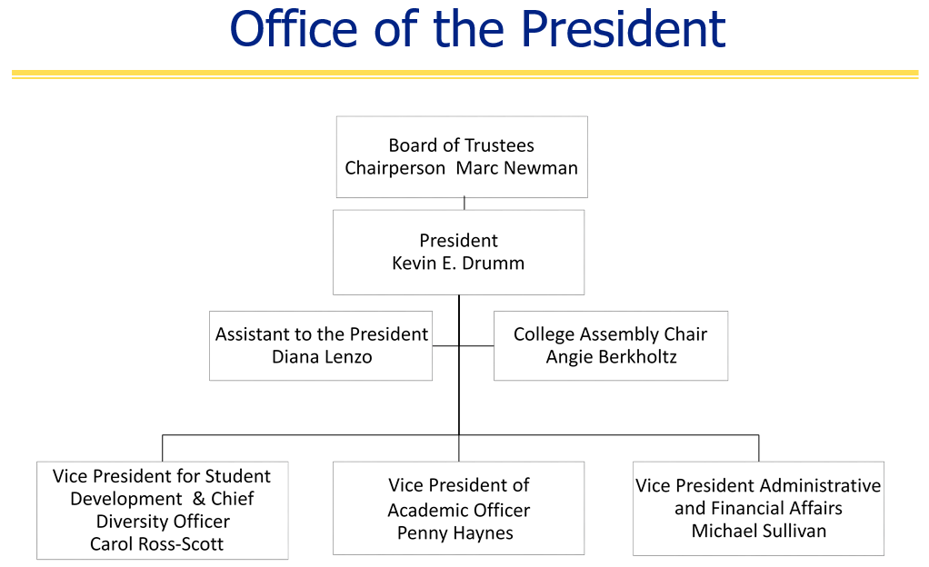
Vice President of
Academic Affairs
Penny Haynes
Vice President for Student Development & Chief Diversity Officer
Carol Ross-Scott
Vice President Administrative and Financial Affairs
Michael Sullivan

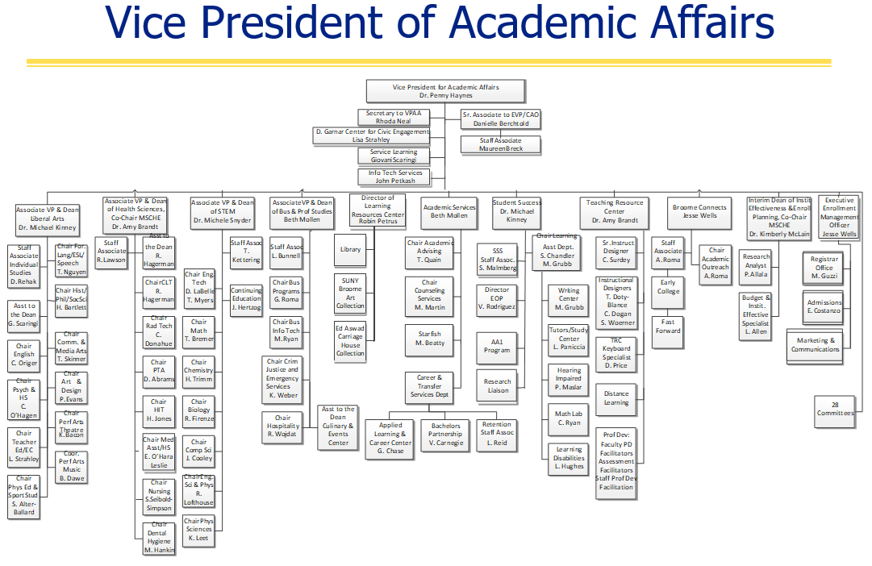

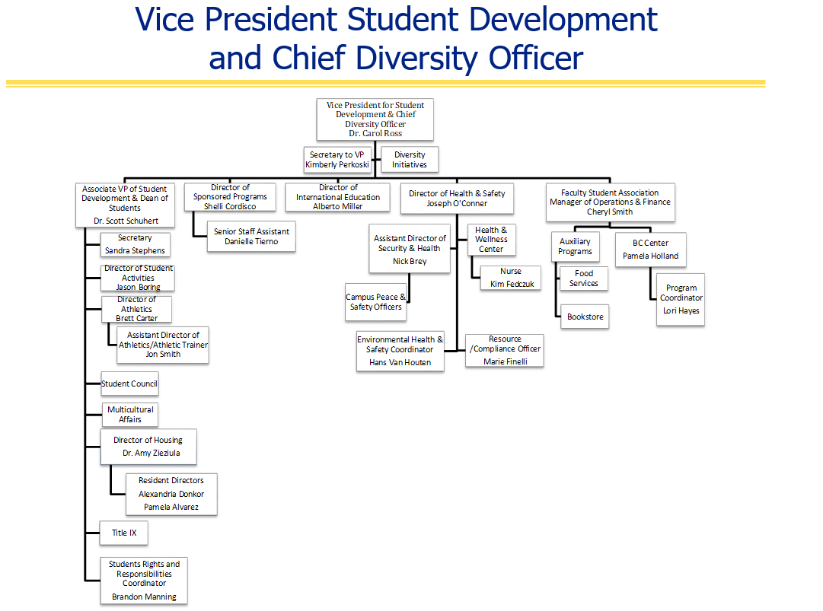

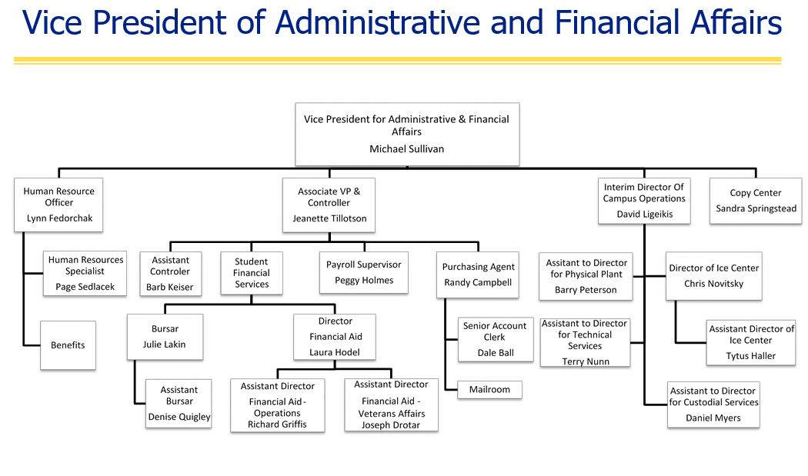

Appendix B: Recommended Organization Charts
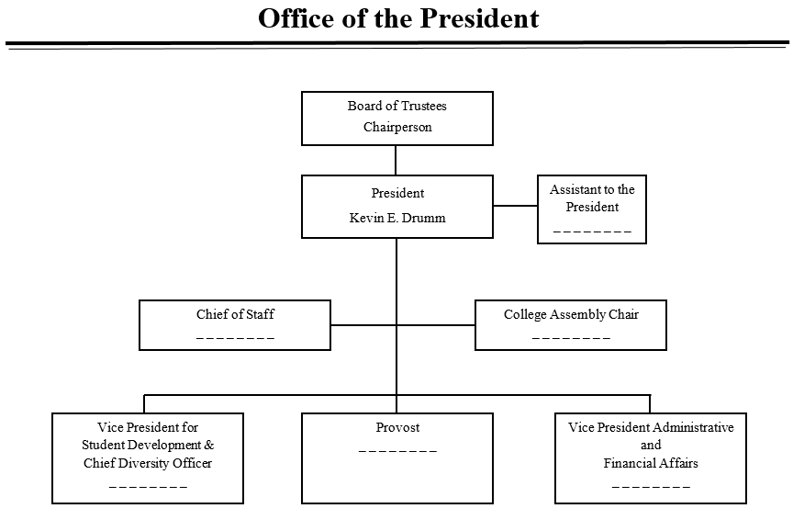

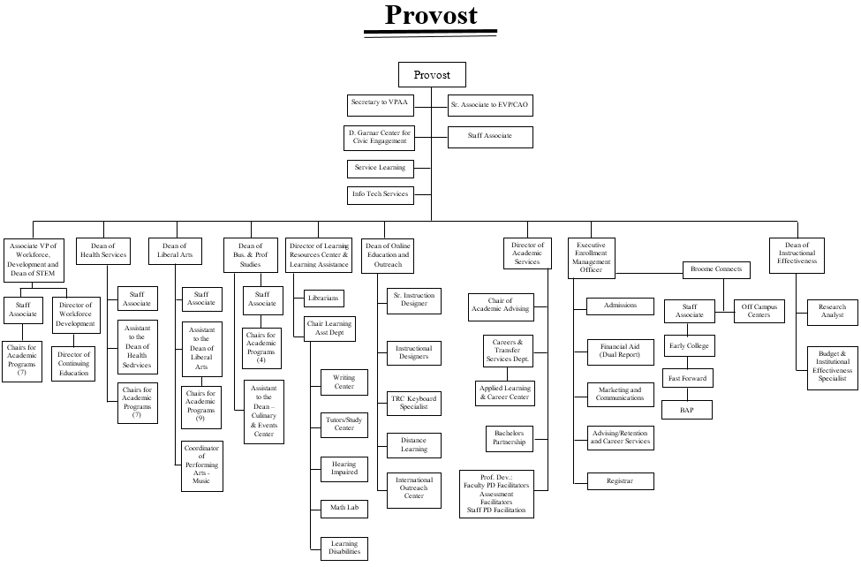

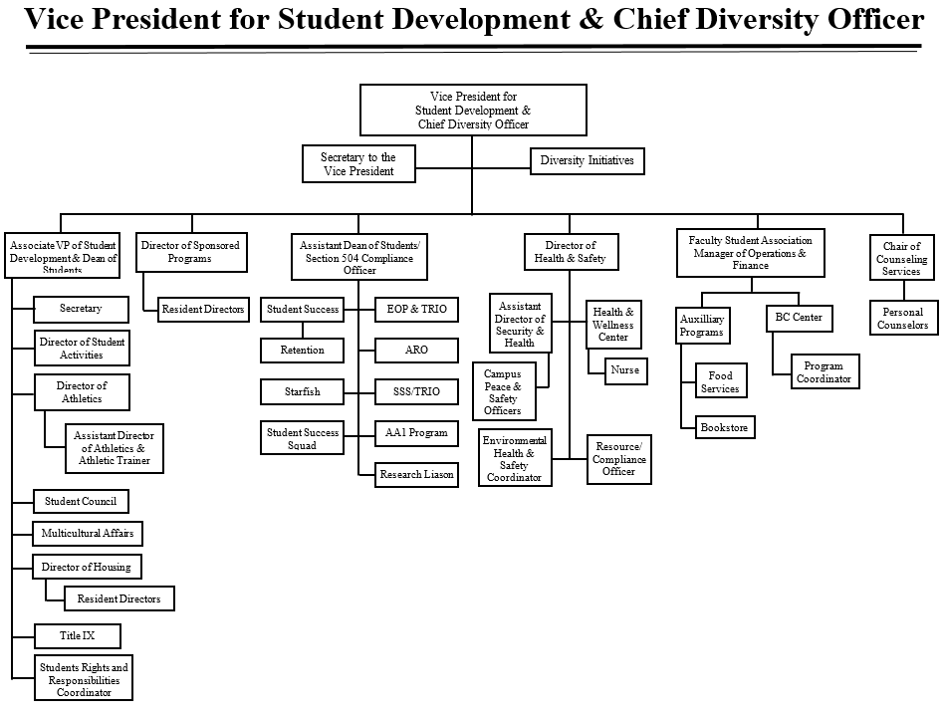
Senior Staff Assistant

